Amendments
- Amend the Grammar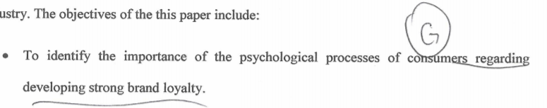
- Don’t use “;”, it should be new paragraph/ point
To recommend the best…..industry
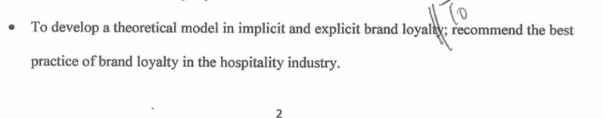
- Focus to explain the 4 stage of oliver framework model
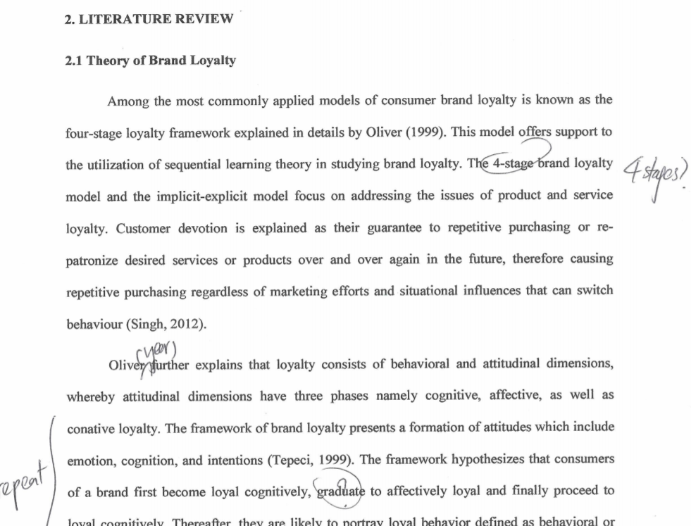
- Terms need to be centralized (e.g. if the first time is use Brand loyalty, after all related also use “Brand loyalty” not others term)
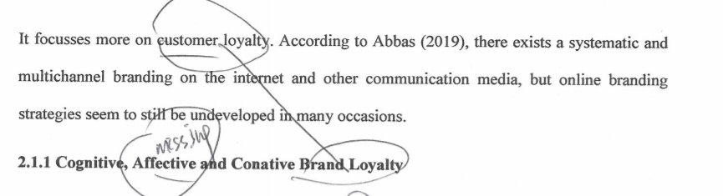
- If the paragraph is talking about “Cognitive Brand Loyalty”, then don’t talk others
e.g. Cognitive…..
Affective…..
Conative…..
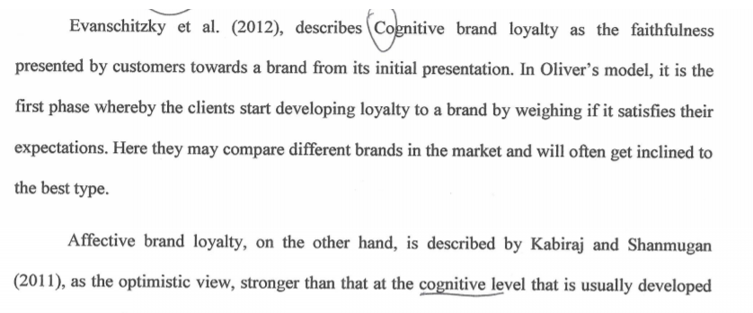

- Need to write in separate paragraphs
Customer Delight: Customer delight definition…..
Customer Satsfaction: Customer Satisfaction definition…..
Customer Delight and customer satisfaction relationship…..
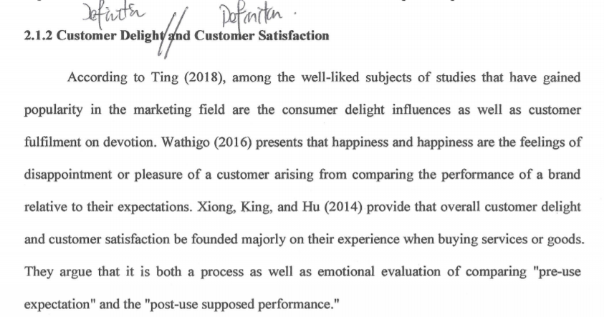
- Because this is talking hospitality industry, therefore don’t talk others
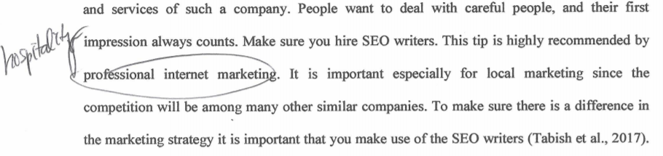
- Add reference
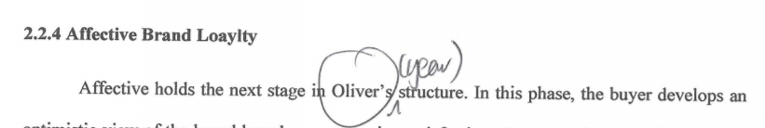

- Only focus talk about conative brand loyalty
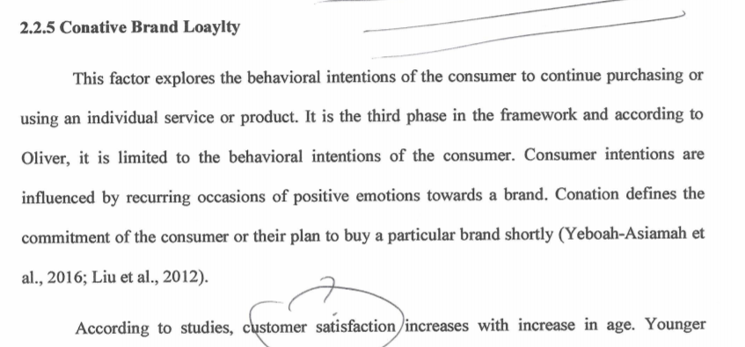
- Talk definition first
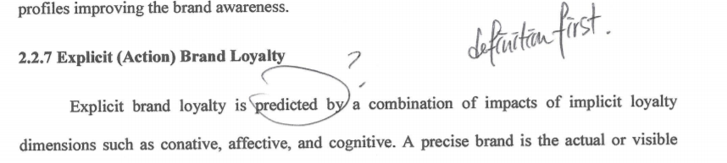
- Is it Customer Satisfaction and delight?
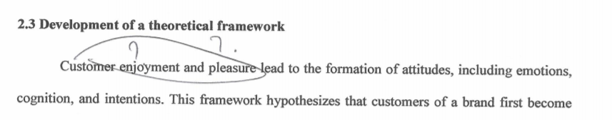

- Add sub-heading to let tutor know which sample you are talking and Hilton need add reference, what is R&P? do you have full name?
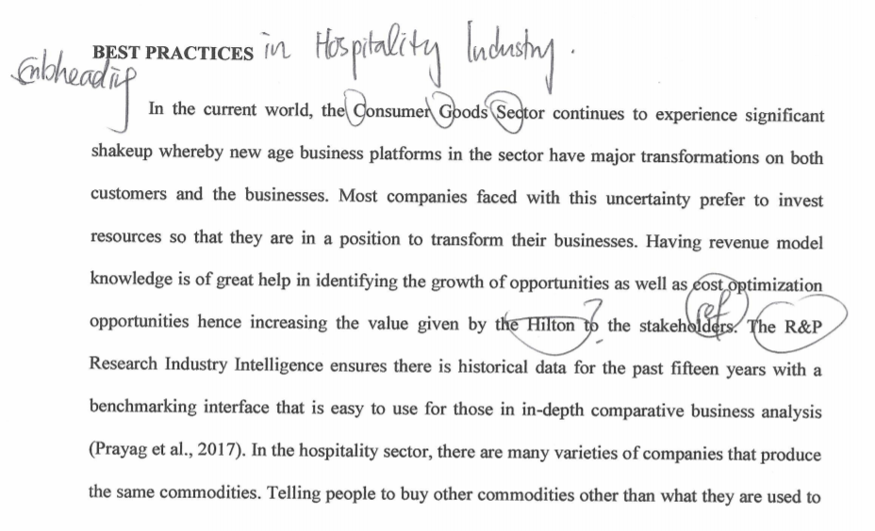
- Explain how to achieve explicit brand loyalty
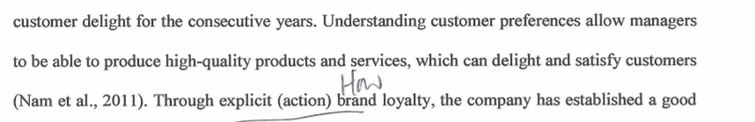
- Set reference to support your idea
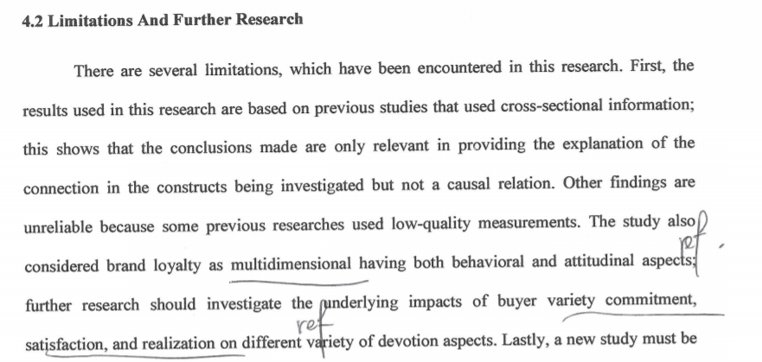
Reference list amendment
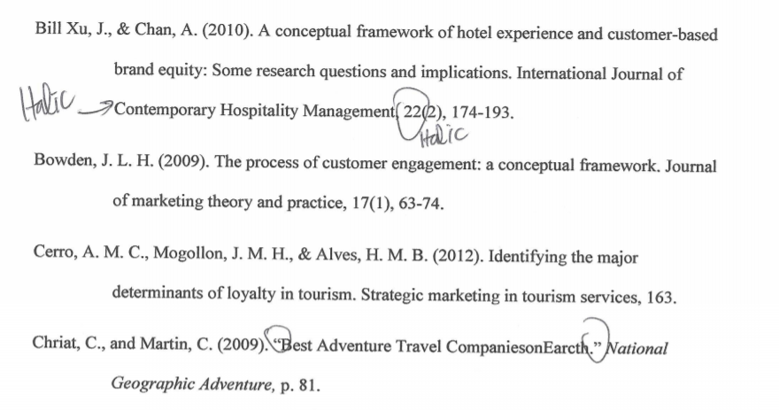
2. you don’t have use this reference in the contents
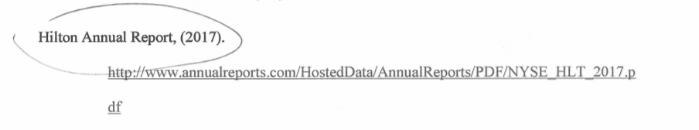
3. please double confirm the reference
